Press release
Great interest for Symposium "Values ​​in Banking"

Utrecht, Wednesday June 14th,
A large audience attended the symposium "Values ​​in Banking" organized by the Association of Credit Unions in the Netherlands (ACUN), held at the Volksbank in Utrecht. Presided over by Arnoud de Roy van Zuydewijn (Chairman of the Supervisory Board), Maurice Oostendorp, Onno Ruding, Matthijs Bouman, Hans Bergsma, Ronald Seinen and Roland Lampe gave their vision on the development of values at financial institutions in the Netherlands.

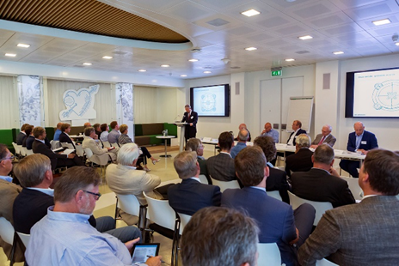
ACUN is a trade association which stimulates, facilitates and supervises the introduction of a system of credit unions in the Netherlands, in accordance with the Act on Supervision of Credit Unions and in accordance with internationally accepted standards.

Our host Maurice Oostendorp (CEO of Volksbank) welcomed the audience with great pleasure.
He dwelled on the history of the Volksbank, its current status and the future new positioning, in which the core values of the bank and all its brands will have a prominent place.

Onno Ruding, involved in the establishment of the Act on the Supervision of Credit Unions (ASCU) stated that "The discussion currently taking place in Europe, including in our country, about the nature of supervision of financial institutions: principle based or rules based, is not a matter of either-or, but of and-and. After the latest financial crisis, the threat of predominantly rules-based supervision is real. In addition to transaction banking, long-term relationship banking requires more attention”.

Matthijs Bouman (economist and journalist) wondered:” if the economy is recovering, why is commercial lending lagging behind? Economic growth without growth in lending is not lasting! IMF research from 2013 shows that such creditless growth is usually not very solid. Without new loans to companies, for new investments, warning lights may soon start flashing. "

Hans Bergsma, Regional Co-operative Westerkwartier and Ronald Seinen, Chairman of the Westerkwartier Credit Union emphasized “that the strength of co-operation is in common values; There are similarities and differences in value patterns at the Westerkwartier Credit Union and the Westerkwartier Regional Co-operative, but as co-operatives, their core values are the same. "

Roland Lampe, director of ACUN presented the state of affairs with credit unions in the Netherlands: " internationally accepted rules for governance, compliance, code of conduct and proper management of credit unions apply. ACUN has established 27 credit unions up to now, has 21 members, 8 associated members, 32 prospects, 105 suspects and 17 project managers; Common Bond Credit Unions have extended more than € 6 million in in loans in two and a half years. In total, some 600 SME entrepreneurs entrusted on average € 10,000, - to the common chest of their credit union. 250 jobs were created or maintained. Together with our members we focus on SME entrepreneurs and offer them Hope (to realize their plans for growth), Confidence (the entrepreneur becomes a member of the common bond) and Coaching (experienced contributing members support starting entrepreneurs with knowledge, experience and networks); The entrepreneur is not alone any more in his or her business ".

During the panel discussion, the question was asked why it takes so long for credit unions to establish themselves and start lending. Roland Lampe: "The setting up of credit unions is not a simple thing to do. These are institutions that work with other people’s money, which creates special responsibilities, and requires solid checks and balances. Strong steps have been taken within ACUN over the last year. Together with well-known market parties as our strategic partners, we are on our way to a larger number of credit unions for more accessible lending to SMEs. "
___________________________________________________________________________________

For photos, thanks to Walter Sietinga en Marco Keyzer, see http://bit.ly/2sEg8gx. Presentations can be viewed on http://www.dekredietunie.nl/leden/ . For more information on the Association of Credit Unions in the Netherlands, you may contact: Roland Lampe +31 (0) 6 53 20 05 90 or rlampe@dekredietunie.nl Mesdagstraat 57, 2596 XV, The Hague,

